#1

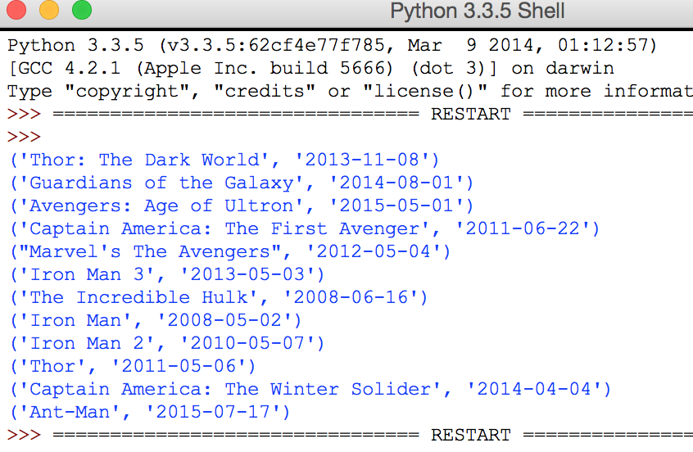

#2

Black Widow

Iron Man

Nick Fury

Whiplash

Pepper Potts

War Machine

Howard Stark

#3

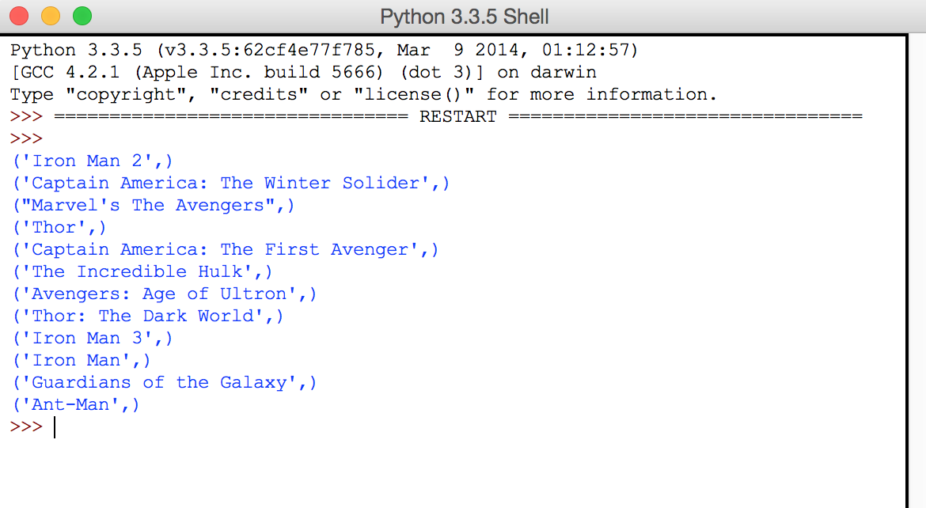

#4

wrong

#5

(2 , 0 , 30 , ‘Thor” , “Marvels the Avengers”)

#6 – is listed in character id’s not name

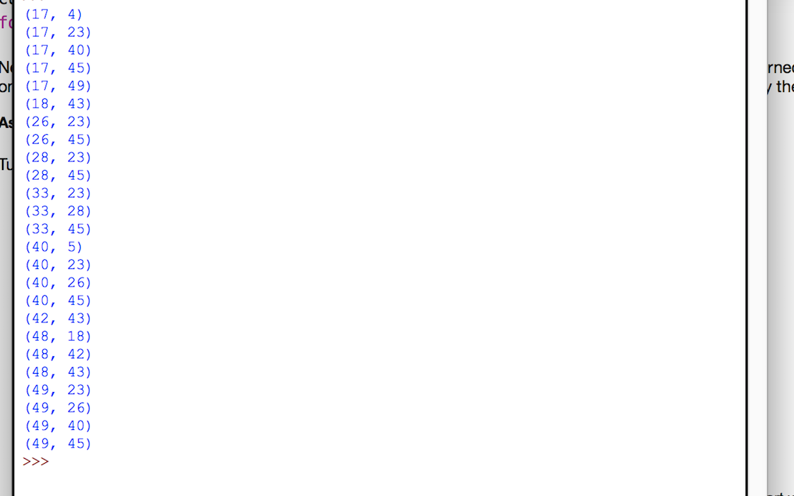

#7 – max count and movie id #

(16,2)

#8

Nick Fury

#9

Howard Stark

Peggy Carter

Captain America

Hank Pym

#10

Luis and Loki